**Vinoba Bhave University**



A Project Report On

***ONLINE LIBRARY MANAGEMENT SYSTEM***

Submitted By

Name: - Piyush Parnov

Roll No.

Course: - MCA

Semester: - 6

**ACKNOWLEDGEMENT**

I would like to express my special thanks of gratitude to my parents, siblings, friends and relatives who supported me to do this project on ‘**ONLINE LIBRARY MANAGEMENT SYSTEM’.**

This also helped me in doing a lot of research and I come to know about so many new things.

I am really thankful to all of them.

**CERTIFICATE**

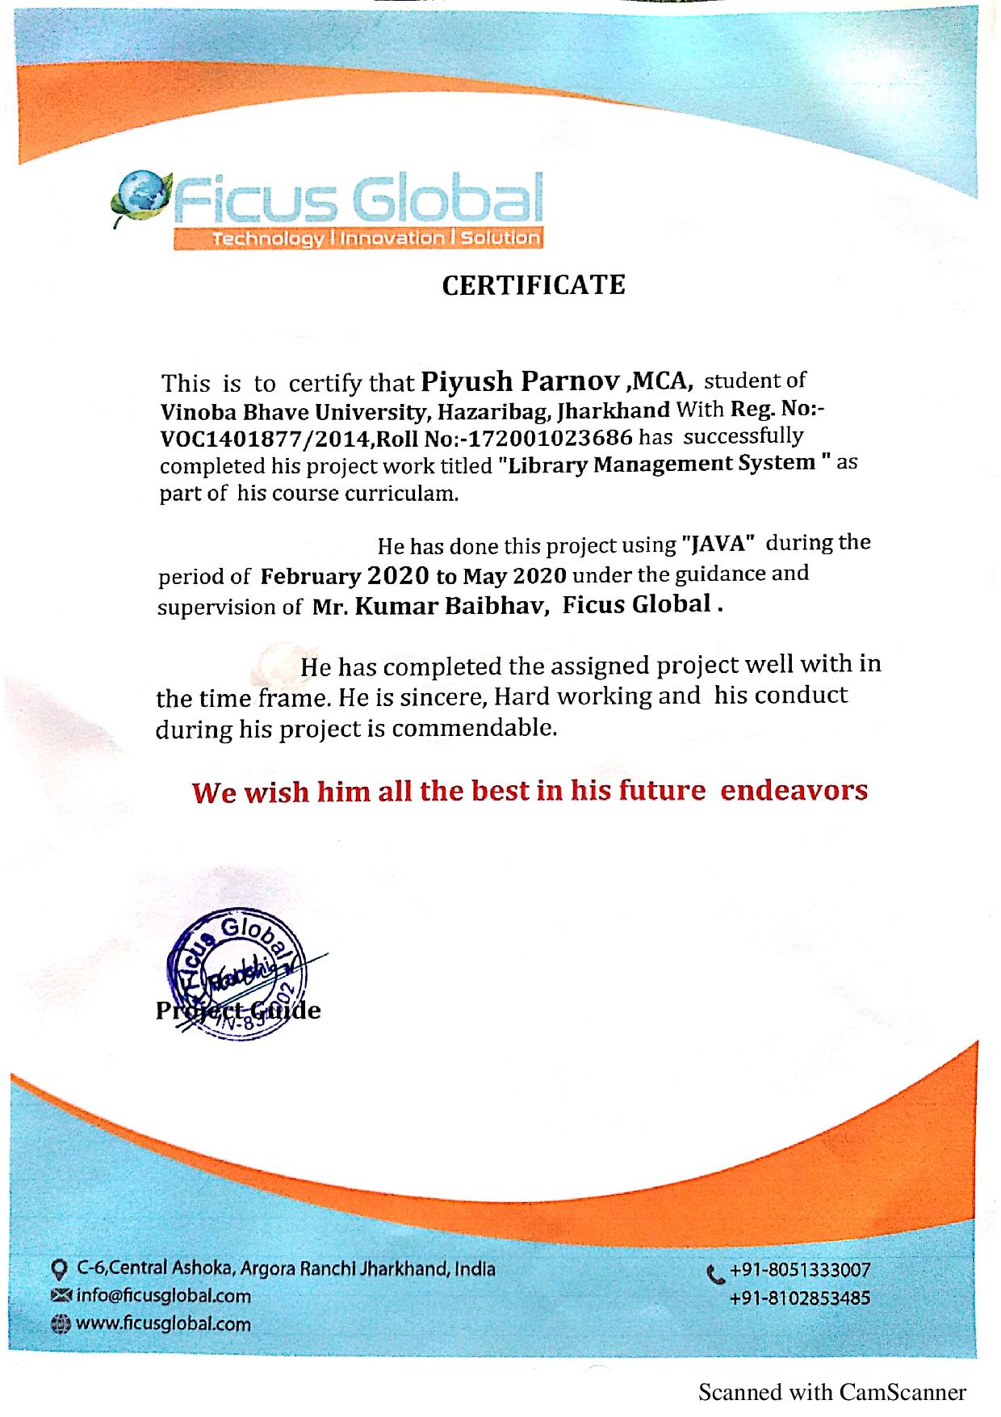

**INTRODUCTION:**

Library Management System is an application which refers to library systems which are generally small or medium in size. It is used by librarian to manage the library record various transactions like issue of books, return of books, addition of new books, addition of new students etc. Books and student maintenance modules are also included in this system which would keep track of the students using the library and also a detailed description about the books a library contains.. In addition, report module is also included in Library Management System. If user’s position is admin, the user is able to generate different kinds of reports like lists of students registered, list of books, issue and return reports. All these modules are able to help librarian to manage the library.

**PURPOSE:**

* The purpose of this project is to provide a friendly environment to maintain the details of books and library members.
* The main purpose of this project is to maintain easy circulation system using computers and to provide different reports.
* Improved user service through greater access to accurate information.
* Due to computerized information it reduces the risk of paper work such as file lost, file damaged and time consuming. It can help user to manage the transaction or record more effectively and timesaving.

**SCOPE:**

* The document only covers the requirements specifications for the Library Management System. This document does not provide any other information about Library Management System
* This document does not provide any other references to the other component of the Library Management System.
* All the dependencies are also included in this document.
* The system is developed to cope up with the current issues and problems of library.
* This project is basically updating the manual library system into a software based application so that the user cans details of their account availability of books etc.
* After computerized system is implemented less human force will be required to maintain the library thus reducing the overall cost.

**FUCTIONAL REQUIREMENTS:**

* The system must only allow user with valid id and password to enter the system .The system performs authorization process which decides what user level can access to. -The user must be able to logout after they finished using system.
* System must be able to search the database based on select search type. User can request for book etc.
* System must be able to update number of books and able to enter issue and return date information.
* If the book is not returned by the user and he or she lost the book fine must be given by him or her.
* A user can issue a book up to a limited number.

**NON-FUCTIONAL REQUIREMENTS:**

EFFICIENCY REQUIREMENT:

When a library management system will be implemented librarian and user will easily access library as searching and book transaction will be very faster.

RELIABILITY REQUIREMENT:

The system should accurately performs member registration, member validation, report generation, book transaction and search

USABILITY REQUIREMENT:

The system is designed for a user friendly environment so that student and staff of library can perform the various tasks easily and in an effective way.

SAFETY REQUIREMENTS:

The database gets crashed at any time due to virus or operating system failure. Therefore, it is required to take the database backup.

SECURITY REQUIREMENTS:

 A functional security requirement is something that describes functional behaviour that enforces security. It can be directly tested and observed

**WORK BREAKDOWN STRUCTURE (WBS):**

***LIBRARAY MANAGEMENT SYSTEM* 1.0**

**1.2** TRANSACTION

**1.1** SEARCH

**1.3** UPDATE

**1.4** REPORT

1.1.1 Register 1.2.1 Return Book 1.3.1 Update Books 1.4.1 Fine

1.1.2 Login 1.2.2 Issue Book 1.3.2 Update Research 1.4.2 Report

1.1.3Search Book 1.2.3Availability 1.3.3 Update Reader 1.4.3 Logout

1.1.4Search Reader 1.2.4 Validation

1.2.5 Completion

**CRITICAL PATH:**

|  |  |  |
| --- | --- | --- |
| **ACTIVITIES** | **DEPENDENCIES** | **TIME DURATION** |
| Register A | - | 2 |
| Login B | A | 1 |
| Book Request C | B | 2 |
| Check Availability D | C | 1 |
| Validate Reader E | B | 3 |
| Create Transaction F | E | 4 |
| Validate Transaction G | F | 5 |
| Return Book H | G | 9 |
| Book Issue I | G,H | 3 |
| Generate Fine J | H | 6 |
| Update Books K | H,I | 10 |
| Update Research L | I,H | 11 |
| Transaction Complete M | G,K,L | 20 |
| Logout N | M,B | 1 |

**ACTIVITY GRAPH:**

**L**

**H**

**J**

**N**

**C**

**D**

**G**

**K**

**M**

**I**

**F**

**B**

**E**

**A**

A+B+N=2+1+1=4

A+B+C+D=2+1+2+1=6

A+B+E+F+G+M+N=2+1+3+4+5+20+1=36

A+B+E+F+G+I+K+M+N=2+1+3+4+5+3+10+20+1=49

A+B+E+F+G+I+L+M+N=2+1+3+4+5+3+11+20+1=50

A+B+E+F+G+H+J=2+1+3+4+5+9+6=30

A+B+E+F+G+H+L+M+N=2+1+3+4+5+9+11+20+1=56

A+B+E+F+G+H+K+M+N=2+1+3+4+5+9+10+20+1=55

**A+B+E+F+G+H+I+L+M+N=2+1+3+4+5+9+3+11+20+1=59 (CRITICAL PATH)**

**ENTITY RELATIONSHIP DIAGRAM (ERD):**

LOGIN

AUTHENTICATION SYSTEM

STAFF

MAINTAIN

ISSUE

KEEPS TRACKS

RESERVE

BOOKS

N

USERS

RETURN

**DATA FLOW DAIGRAM (DFD):**

CONTEXT LEVEL DIAGRAM /OTH LEVEL:

UPDATE

SEARCH

Update books

Answer is given back to the user display updated info

User search any book

Availability of book check valid user

LOGIN

TRANSACTION

If present then show details user login to library

Ask for book reservation

Fine generation report Book is issued

READER

Display to the user

REPORT

**1th LEVEL:**

search for a book request for a book

***READER***

***LIBRARIAN/ADMIN***

Not Available

Check for availability Return Status

Check

Enter details of fine report

Transaction Book

Update

Issue Process

**TECHNOLOGY USED**

**REST API**

What is REST? REST stands for *Representational State Transfer*, which is an architecture style for designing distributed systems. A web service based on the REST architecture is referred as RESTful web services.

CRUD stands for **C**reate, **R**ead, **U**pdate and **D**elete, which refers to the four operations on persistence storage.

RESTful service uses the following HTTP methods to map the HTTP request to CRUD operations.

| **HTTP Method** | **CRUD Operation** | **Description** |
| --- | --- | --- |
| POST | Create | Create a new resource ( equivalent to sql INSERT statement) |
| GET | Read | Retrieve a resource ( equivalent to sql SELECT statement) |
| PUT/PATCH | Update | Update or modify a resource ( equivalent to sql UPDATE statement) |
| DELETE | Delete | Delete a resource ( equivalent to sql DELETE statement) |

**Tools and technologies used for this application are-**

* Spring Web MVC 4.3.10.RELEASE
* Spring OXM 4.3.10.RELEASE
* Jackson API 2.8.7
* Hibernate 5.2.11.Final
* c3p0 0.9.5.2
* MySQL 5.7.12
* Java SE 1.8
* Maven 3.3.9
* Eclipse Neon.3
* Apache Tomcat 7.0.47

**SCREENSHOTS**

